

**Machine Learning Using Python**

**Internship**

**TOPIC**

Drowsiness Detection System

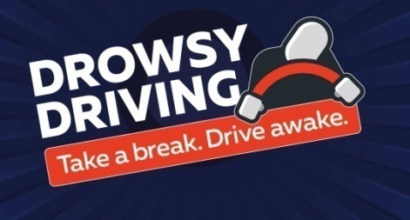

**MENTOR**

Aishwarya Saxena

**INDEX**

|  |  |  |
| --- | --- | --- |
| **SR NO** | **TOPIC** | **PAGE NO** |
| 1 | INTRODUCTION | 3 |
| 2 | OBJECTIVE | 3 |
| 3 | BACKGROUND | 3 |
| 4 | HARDWARE AND SOFTWARE REQUIREMENTS | 4 |
| 5 | CODING | 5 |
| 6 | ACTUAL OUTPUT SCREENSHOTS | 7 |
| 7 | FUTURE SCOPE | 8 |
| 8 | CONCLUSION | 8 |
| 9 | BIBLIOGRAPHY AND REFERENCES | 8 |

**I.INTRODUCTION:**

Driver drowsiness driving is one of the main reasons for road accidents. Driver drowsiness detection is a car safety technology which prevents accidents when the driver is getting drowsy. As per 2018 survey, 21% of all fatal accidents are due to drowsy driving. 60 percent of adult drivers or about 168 million people have driven a vehicle while feeling drowsy in the past year. In 2019 survey it shows that exhausted drivers who doze off at the wheel are responsible for about 40% of road accidents, says a study by the Central Road Research Institute (CRRI). The survey highlights the facts that total numbers of traffic deaths are excessive because of drowsiness of the driver and it increases each year. Driving a vehicle in a crowded road has become a nightmare because of the road conditions, poor weather conditions, haste to reach the destination and excess of traffic. Based on Acquisition of video from the camera (using open CV) that is in front of driver perform real-time processing of an incoming video stream in order to infer the driver’s level of fatigue if the drowsiness is estimated then it will give the alert by sensing the eyes.

**II. OBJECTIVE:**

A computer vision based thoughts have been used for the creation of a Drowsy Driver Detection System.It is the car safety technology which spares the life of the driver by avoiding mishaps when the driver is getting distractions.The primary goal is to initially plan a framework to distinguish driver's sluggishness by persistently checking retina of the eye. To caution the driver on the identification of laziness by utilizing ringer or alert. Speed of the vehicle can be reduced. Traffic management can be maintained by reducing the accidents. The structure can work just when the eyes are found, and work in encompassing lighting conditions too.

**III. BACKGROUND :**

Drowsiness is a serious concern when driving and can cause accidents because it impairs the elements of human performance that are critical to safe driving: slower reaction time, reduced vigilance, deficits in information processing.

a)Existing drowsiness detection methods include:

Carnegie-Mellon Research Institute: PERCLOS SystemsPERCLOS (percentage closure) is defined as the measurement of the percentage of time the pupils of the eyes are 80% or more occluded over a specified time interval. It has been found that PERCLOS is a reliable measure in detecting drowsiness.

b) Head position metrics:

Systems have been devised such that the head position of the driver is detected and when the head leaves the headrest past a certain threshold percentage, the system alerts the driver.

**IV. HARDWARE & SOFTWARE REQUIREMENTS :**

**Hardware Requirements:**

|  |  |
| --- | --- |
| HARDWARE TOOLS | MINIMUM REQUIREMENTS |
| PROCESSOR | i3 or above |
| HARD DISK | 4 GB |
| RAM | 4 GB |
| MONITOR | 17’’COLOURED |
| MOUSE | OPTICAL |
| KEYBOARD | 122 KEYS |

**Software Requirements:**

|  |  |
| --- | --- |
| SOFTWARE TOOLS | MINIMUM REQUIREMENTS |
| PLATFORM | Windows, Linux, Mac-OS |
| OPERATING SYSTEM | Windows, Linux, Mac-OS |
| TECHNOLOGY | Machine –Learning Python |
| SCRIPTING LANGUAGE | Python |
| IDE | PyCharm |

**V. CODING:**

**A) Libraries (pre requisites):**

* **Numpy**  - pip install numpy (to expand the shape of array )
* **OpenCV –** pip install opencv-python (face and eye detection).
* **TensorFlow –** pip install tensorflow (keras uses TensorFlow as backend).
* **Keras –** pip install keras (to build our classification model).
* **Pygame –** pip install pygame (to play alarm sound).

**B) Code:**

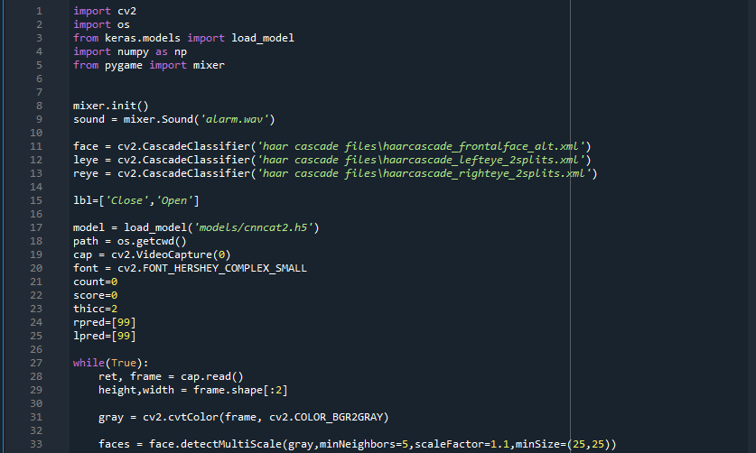

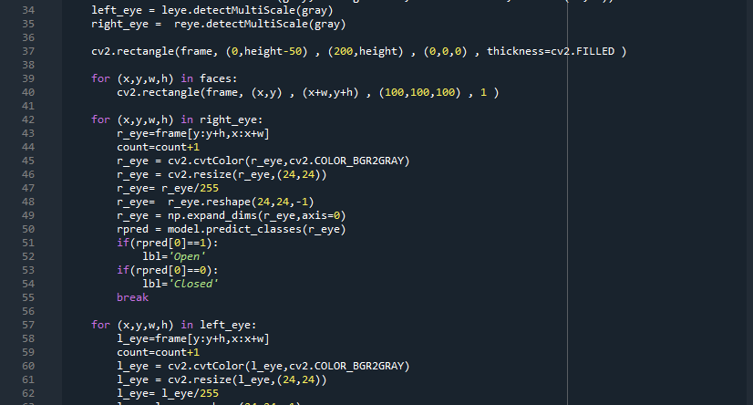

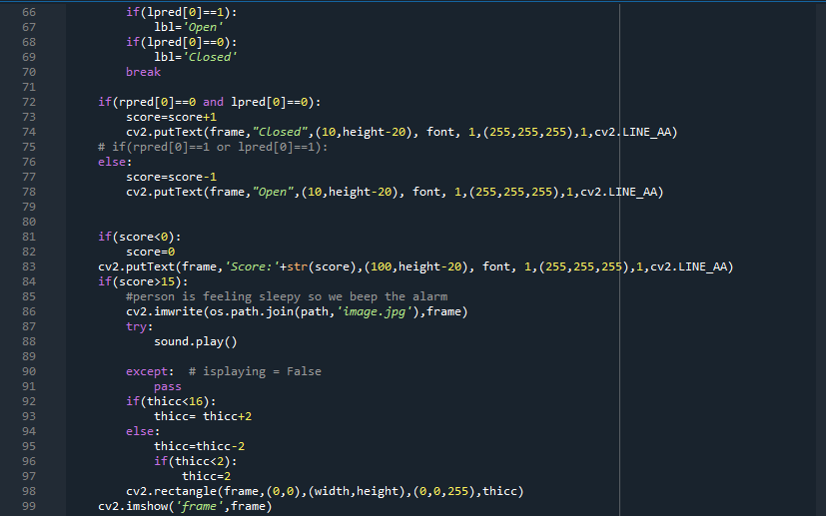

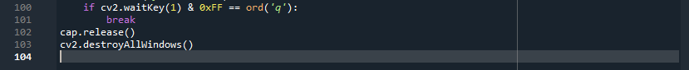

**VI. ACTUAL OUTPUT SCREENSHOTS:**

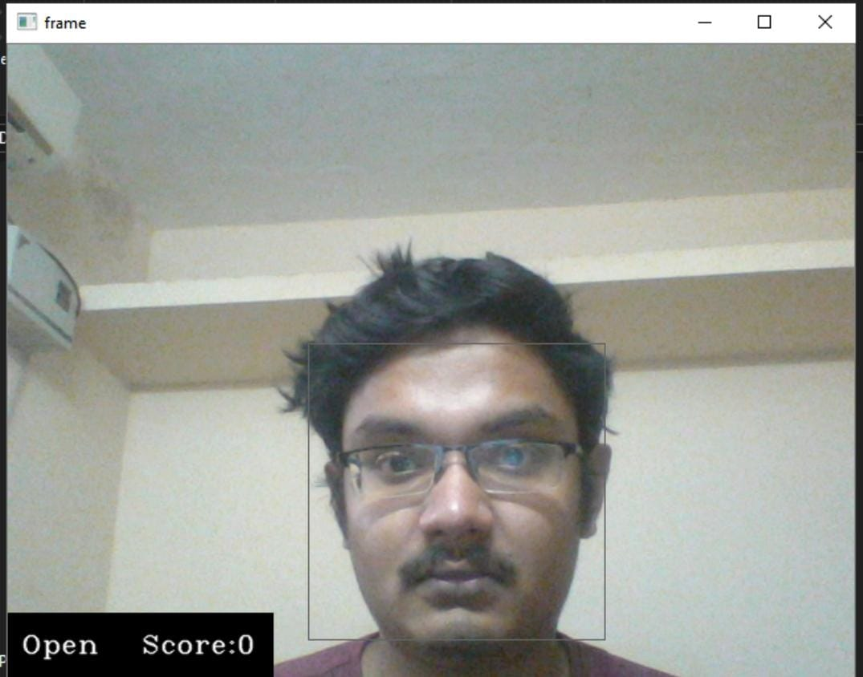

Figure 6.1

The eyes is opened and the drowsiness score is 0 indicates that person is awake as shown in Figure 6.1



Figure 6.2

The eyes is closed and the drowsiness score is 19 indicating that person is sleepy as shown in Figure 6.2

**VII. FUTURE SCOPE:**

A device that monitors the eyes and indicates a percentage on how much a person is drowsy. During the monitoring the person's eye can be half closed or fully open depending on the position it will give us the percentage. The device is attached to a 4 wheeler or heavy transport (bus, lorry etc) to prevent accidents. Future scope of this project is with the device being attached to a car, lorry any heavy transport an alert system will also be attached so if the driver is drowsy and has crossed the limit an alert signal will be sent to the police.

**VIII. CONCLUSION:**

The Drowsiness Detection System developed based on eye closure of the driver can differentiate normal eye blink and drowsiness and detect the drowsiness while driving. The proposed system can prevent the accidents due to the sleepiness while driving. The system works well even in case of drivers wearing spectacles and even under low light conditions if the camera delivers better output. In this proposed project, the discussion regards the avoidance of accidents due to drowsiness is discussed with eye blink and corresponding system was developed which is capable of detecting drowsiness in a rapid manner. Here we used OpenCV to detect faces and eyes using a Haar cascade classifier and then we used a CNN (Conventional Neutral Network) model to predict the status.

**IX. REFERENCES AND BIBLIOGRAPHY:**

[1]Datasets (<https://github.com/opencv/opencv/tree/master/data/haarcascades>)

[2]Models ([https://keras.io/api/models](https://keras.io/api/models/))

[3]Numpy ([https://numpy.org/doc/stable)](https://numpy.org/doc/stable/)

[4]Alarm System (<https://www.pygame.org/wiki/tutorials>)

[5] [Eddie E. Galarza](https://www.researchgate.net/scientific-contributions/2138586791_Eddie_E_Galarza) and [Fabricio D. Egas](https://www.researchgate.net/scientific-contributions/2137245589_Fabricio_D_Egas) “Real Time Driver Drowsiness Detection Based on Driver’s Face Image Behavior Using a System of Human Computer Interaction Implemented in a Smartphone” published on January 2018 .Available : DOI: [10.1007/978-3-319-73450-7_53](https://www.researchgate.net/deref/http%3A%2F%2Fdx.doi.org%2F10.1007%2F978-3-319-73450-7_53)

[6] [Mohsen Poursadeghiyan](https://www.ncbi.nlm.nih.gov/pubmed/?term=POURSADEGHIYAN%20M%5BAuthor%5D&cauthor=true&cauthor_uid=30320012), [Adel Mazloumi](https://www.ncbi.nlm.nih.gov/pubmed/?term=MAZLOUMI%20A%5BAuthor%5D&cauthor=true&cauthor_uid=30320012),[Gebraeil Nasl Saraji](https://www.ncbi.nlm.nih.gov/pubmed/?term=NASL%20SARAJI%20G%5BAuthor%5D&cauthor=true&cauthor_uid=30320012), [Mohammad Mehdi Baneshi](https://www.ncbi.nlm.nih.gov/pubmed/?term=BANESHI%20MM%5BAuthor%5D&cauthor=true&cauthor_uid=30320012), [Alireza Khammar](https://www.ncbi.nlm.nih.gov/pubmed/?term=KHAMMAR%20A%5BAuthor%5D&cauthor=true&cauthor_uid=30320012), And [Mohammad Hossein Ebrahimi](https://www.ncbi.nlm.nih.gov/pubmed/?term=EBRAHIMI%20MH%5BAuthor%5D&cauthor=true&cauthor_uid=30320012) in “Using Image Processing in the Proposed Drowsiness Detection System Design” published on September 2018.

[7] [Prakash Choudhary](https://www.semanticscholar.org/author/Prakash-Choudhary/47833863), Rahul Sharma and [Smarjeet Das](https://www.semanticscholar.org/author/Smarjeet-Das/1517362274) in “A survey paper on Drowsiness Detection and Alarm System for Drivers” published on 2017 (Corpus ID : 212439039)